Itinerary for Excursion, July 27th, Saturday
6:15am: Breakfast in No. 3 Building, Yanyuan Hotel.
7:00am: Tour bus leaves Yanyuan Hotel.
8:30am: Tour of Zhujiajiao Ancient Town.
Please be prepared for the hot weather!
11:15am: Meet at the Meeting Point (to be announced).
11:30am: Lunch at Shanghai Jingyuan Hotel, 300 Xijing Street, Zhujiajiao
Tel: 021-59248888 朱家角镇西井街300号景苑水庄酒店。
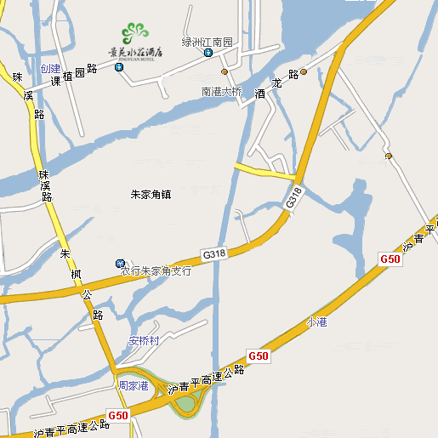
12:30pm: Tour bus leaves Zhujiajiao
2:00pm: Tour Shanghai Museum
4:30pm: Buse leaves Shanghai Museum
6:00pm: Banquet at Yue Xin Hotel, 2606 Songhuajiang Road, Shanghai
Tel: 021-55880777, 55889777 松花江路2606号上海馨悦大酒店。
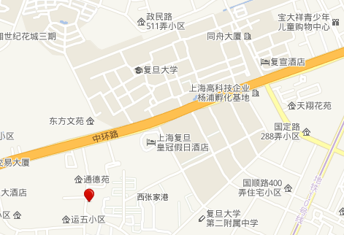
Emergency Contact: BUS Plate 沪B85257
Jing Leng 151-2101-6305

